REGISTRATION FORM
National Seminar on
ECONOMIC CHALLENGES OF COVID-19 ON HEALTH CARE AND EMPLOYMENT SECTOR
24th March, 2022

Name :_________________
Institution :_________________
Designation : Student /Scholar/Faculty
Address :_________________
_________________
_________________
Pin Code :_________________
Mobile No : ________________
E-Mail : ________________
DD No :_________________
(Photo Copy of this Format can be used)
Place:
Date:
Signature of the Participant
https://forms.gle/FZFMiTqeqT77fVWM7

ORGANISING TEAM

Patron
Dr. Sr. Gerardin Jayam, Secretary
President
Dr. Sr. Sophy, Principal
Chairperson
Dr. S. Jeni Sanjana,
Head of the Department

Convener
Dr. A. Sameema & Dr. S. Vimal Dolli
Assistant Professor
Organizing Committee
Dr. J.M. Vinitha Charles
Dr. S. Panimaya Mercy
Ms. J. Josephine Shiny
Dr. A. Babila Kingsly
Ms. M. Sahaya Vennila

Registration Fee
Students : Rs. 200/-
Research Scholars & Faculty: Rs. 250/-
Papers Presenters : Rs. 300/-
Publication fee : Rs.600/-
Kindly send the D.D infavour of
Co-ordinator, Department of Economics, Holy Cross College, Nagercoil
For Further Details
Dr. A. Sameema
 9789330985
Dr. S. Vimal Dolli
 9486604502

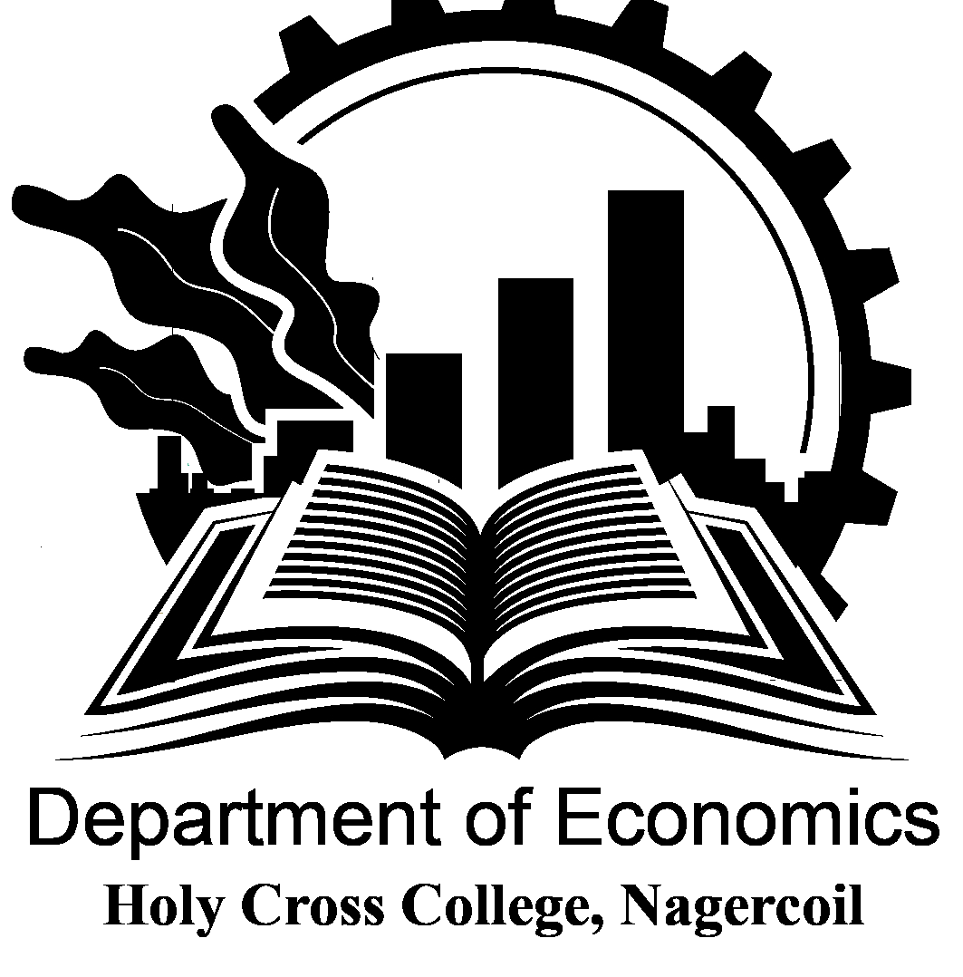

HOLY CROSS COLLEGE (AUTONOMOUS)
Nagercoil – 629 004

National Seminar on
ECONOMIC CHALLENGES OF COVID-19 ON HEALTH CARE AND EMPLOYMENT SECTOR
24th March, 2022



Organised by
PG and Research
Department of Economics
Holy Cross College (Autonomous)
Nagercoil – 629 004

About the College
Holy Cross College, Nagercoil is a Catholic College established and administered by the Congregation of the Sisters of the Cross of Chavanod. Holy Cross College, the first Women’s College in Kanyakumari District was inaugurated on 2nd August 1965. The college stands for total liberation and development of the whole person of the students in order to prepare them to take their rightful place and responsibility in the society. It offers 12 U.G., 10 P.G., 4 M.Phil. 8 Ph.D, programmes. It also offers many skills based, career oriented certificate and diploma courses.
About the Department
The Department of Economics is as old as the college itself. Having emerged as an undergraduate Department in 1967, developed as a PG department in 2003, it has now attained the status of a Research Centre. The department has produced many university rank holders in the past decades. The inter disciplinary PG course Business Economics (Self financed) was started in 2003. From 2016 it has been changed to MA Economics. The department provides opportunities to tap the talents and skills of our students. It promotes entrepreneurial awareness and nurtures social responsibility. It has collaboration with SRAEF, NGO’s and other centers.
About the Seminar
The COVID-19 health crisis in an unprecedented shock that is transforming the lives and livelihoods of individuals around the globe. Its effects are likely to extend beyond the short term into the medium and long term as well. The severe health impacts have been matched by sharp declines in economic activity and upheavals of labour markets. The combination of fear of infection, public guidelines and great uncertainty produced a sharp contraction in economic activity and disrupted global value chains with a deep and widespread shock to the labour market. In addition, state-imposed lockdowns and firms’ closures have had very significant impact, with millions of workers across many countries experiencing a reduction in, or the complete loss of, their livelihoods. As industries were forced to cease operations in order to protect the health of workers and promote compliance with mitigation and containment polices, many countries adopted widespread employment retention schemes and income support schemes to support workers. Whenever possible, employers reorganized their operations to enable remote working arrangements. With this understanding and gain more knowledge the topic Economic Challenges of COVID-19 on Health Care and Employment Sector has been chosen for this seminar.
Call for Papers
Focusing on the above mentioned aspect, we call for research papers from academicians, research scholars and students in any one of the following sub themes or related themes.
- Economic impact of COVID-19 on health care and employment sector
- Challenges faced by health care and employment sector
- Sustainable recovery after COVID-19
Guidelines for paper presentation
- The soft copies of original and unpublished papers should be submitted on or before 15/03/2022 to holycrosseconomics@gmail.com
- The paper should not exceed 5 pages including tables and diagrams
- Font style – Times New Roman, Font size – 12 and line space 1.5
- The selected papers will be published in ISBN book. The additional fee of Rs.600 should be paid for publication.
Programme
9.15 AM : Registration
9.30 AM : Inauguration
Prayer Song : Dept. Choir
Welcome Address : Dr. S. Jeni Sanjana
Head & Assistant Professor
Department of Economics
Release of Magazine
& Felicitation : Dr. Sr. Gerardin Jayam
Secretary
Release of book : Dr. Sr. Sophy
Principal

Key Note Address : Dr. G. Indra Jaculine, Associate Professor of Economics
Sarah Tucker College (Autonomous)
Perumalpuram
Tirunelveli
Vote of Thanks : Dr. J.M.Vinitha Charles
Technical Session
11.30 AM- 12.30 PM: Technical Session-I
Welcome Address : Ms. J.Josephine Shiny
Resource Person : Dr. Manju S. Nair
Professor
Department of Economics
Dean, Faculty of Social Science
University of Kerala
Topic : “Industrial growth performance in India then and now”
Vote of Thanks : Ms. M. Sahaya Vennila
12.30-1.30 PM : Lunch
1.30-2.30 PM : Paper Presentation
2.30-3.15 PM : Valedictory
Welcome Address : Dr. A. Babila Kingsly
Valedictory Address: Dr. A. Anandhy
Head & Associate Professor
Department of Economics
Scott Christian College (Autonomous)
Nagercoil
Distribution of Certificates
Vote of Thanks : Dr. A. Sameema

National Anthem

